Central Nevada Health District Epidemiology Program
November 2023 – February 2024 update
The CNHD Epidemiology Program consists of one Program Manager and one Disease Investigator.
A monthly respiratory surveillance report is provided to the CNHD board members, to outline current respiratory virus trends that are being monitored. This report summarizes influenza activity, influenza-like-illness activity, communities with higher influenza rates, influenza vaccine rates, influenza hospitalizations and deaths; an update on Covid-19 rates, Covid-19 vaccination rates, Covid-19 hospitalization rates and an update on Covid-19 deaths; RSV rates, RSV hospitalization trends; and preventative measures CNHD recommends for the respiratory viruses.
A monthly syndromic surveillance report is also provided to the CNHD board members. This report monitors syndromes the CNHD board is interested in for suicide, drug overdose and opioid deaths within the CNHD communities. Monthly trends are reported and compared to the previous month’s queries.
The Disease Investigator for CNHD is receiving training on general communicable disease investigations and sexually transmitted disease investigations. We are hopeful the Disease Investigator will be prepared the first week of March to begin taking on some STD investigations, and then within 1-2 months, additional general communicable disease investigations.
In February, the Disease Investigator and the Epidemiology Program Manager attended the foodborne outbreak training in Las Vegas, NV.
The Epidemiology Program is creating program wide policies and procedures for disease investigations, disease investigation expectations, disease investigation timelines, and creating new case report forms specific to the CNHD program.
The Epidemiology Program has established a 24-hour outbreak response phone number and an outbreak fax line for reporting.
The Epidemiology Program Manager, the Environmental Health Program Manager, and the State’s Infection Preventionist have met with two of the three hospitals that serve the CNHD communities in the month of January. The third hospital (Banner Churchill meeting will be held at the end of February). The hospitals’ leadership team and laboratory representatives from Pershing General Hospital and from Mount Grant Hospital have met with CNHD to discuss reporting to CNHD as the new local health authority, implementing policies and procedures for serious healthcare associated infections to reduce transmission and to prevent spread within the hospitals. Discussions specifically around C. Auris and the need for education for staff and creating policies on screening new patients to stop the spread of infection within the hospital and the community. Contact information cards were passed out to staff for specific diseases CNHD would like the laboratory to notify about immediately.
The Epidemiology Program is working with a small group to get information on the diseases CNHD will investigate onto the CNHD website. Information on the diseases including how they are transmitted, incubation periods, exposure sources and prevention will be provided on the website. Information for reporting diseases will also be provided on the CNHD website.
Pamphlets and posters have been created on the Epidemiology Program within CNHD have been passed out to local senior centers, libraries, recreation centers, youth clubs and to some of the schools. CNHD was able to obtain boxes of take home Covid-19 kits – to disperse within the community at various locations for residents to pick up.
The school district nurses from the four counties CNHD serves have been met and provided information on reporting and respiratory guidance within the schools.
Please see the next page for an example of the monthly respiratory surveillance report and monthly syndromic surveillance report.

Purpose
Syndromic Surveillance
State and local health districts use syndromic surveillance data to investigate and respond to potential health threats. Syndromic surveillance provides public health officials with a timely system for detecting, understanding, and monitoring health events. By tracking symptoms of patients in emergency departments – before a diagnosis is confirmed – public health can detect unusual levels of illness to determine whether a response is needed. This data can serve as an early warning system for public health concerns (i.e., flu outbreaks or opioid overdoses and natural disasters). The data collected is received from emergency departments, urgent and ambulatory care centers, inpatient healthcare settings and laboratories. Electronic health data is integrated through a shared platform called BioSense. The public health community uses analytic tools on this platform to analyze data received as early as 24 hours after a patient’s visit to a participating facility.

Using Syndromic Surveillance within the Counties
Our objective will be to utilize syndromic surveillance to identify clusters early, before diagnoses are confirmed; ultimately to mobilize a rapid response, to reduce morbidity and mortality within our communities.

Current Syndromes Being Monitored
- Suicide
  - Including suicidal ideation, suicide attempts, and other chief complaints associated with suicide.
- Drug Overdose
  - Including cocaine, heroin, and opioid overdose.
- Opioid deaths

This report will compare January 2024 data to December and November 2023 data.

Monitoring of Suicide Data
- January 2024 data.
  - Six alerts/warnings were identified.
    - Two on 1/11/2024, both were white males from Churchill County ages 16 and 36.
    - Two on 1/16/2024, one white female from Mineral County age 39 and one white female from Churchill County age 73.
    - One on 1/17/2024, white male from Eureka County age 28.
    - One on 1/18/2024, white female from Churchill County age 16.

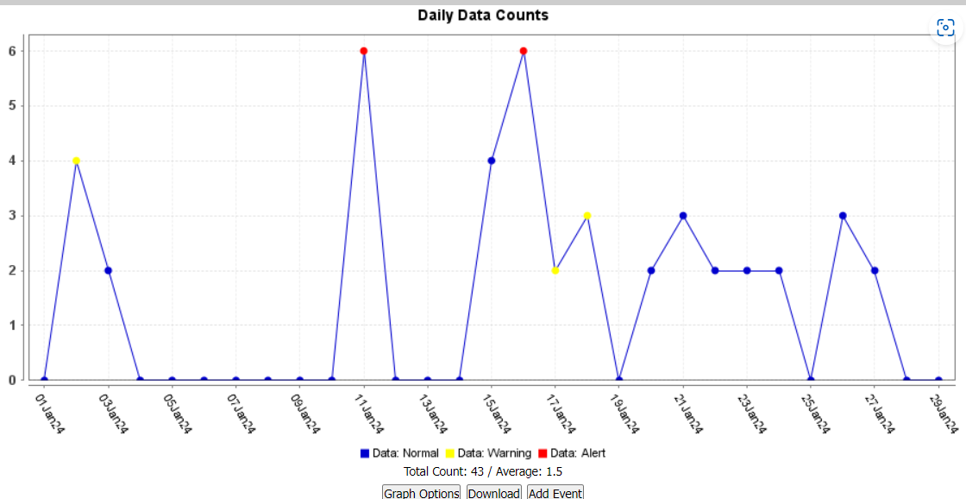

- December 2023 data.
  - Two alerts were identified on 12/31/23.
    - Ages 55 and 13 years of age.
    - From Churchill County.
    - See daily counts below. Normal data which does not warrant an alert or warning is in blue. These levels are identified by alarm generating detectors.
    - A blue data dot means nothing detected. A yellow data dot means 1-2 cases are detected. A Red data dot means 3 or above are detected. The information is analyzed to determine if the alert is accurate.
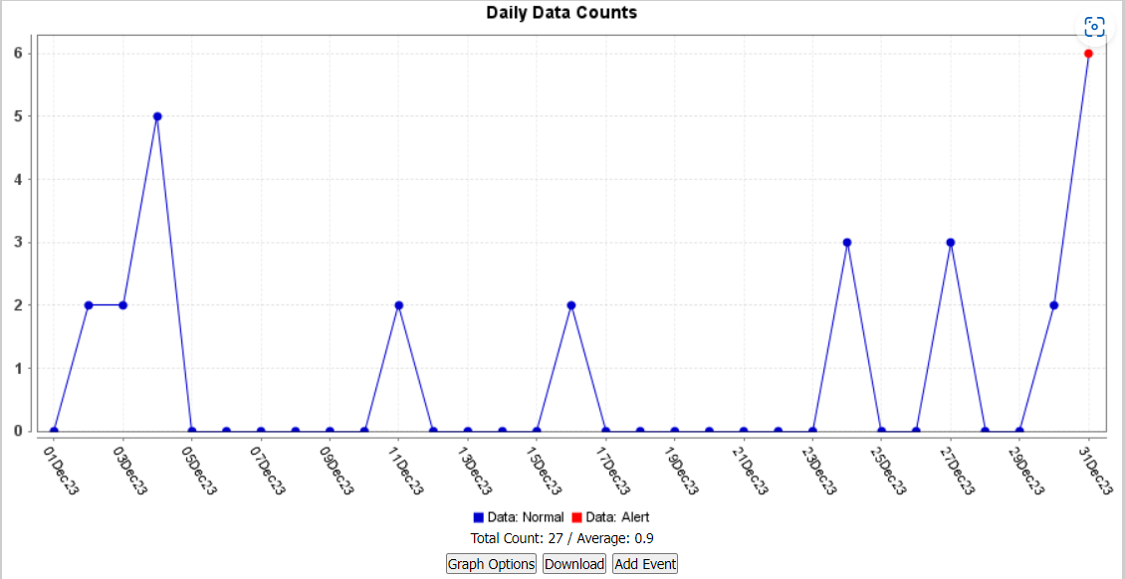
- November 2023 data.
  - Six alerts/warnings for November 2023.
    - Two alerts on 11/4/23 (both from Churchill County aged 49 and 39)
    - Two alerts on 11/12/23. (One from Churchill and one from Mineral County aged 12 and 32).
  - Two alerts on 11/21/23. (One from Churchill and one from Pershing County aged 36 and 75).
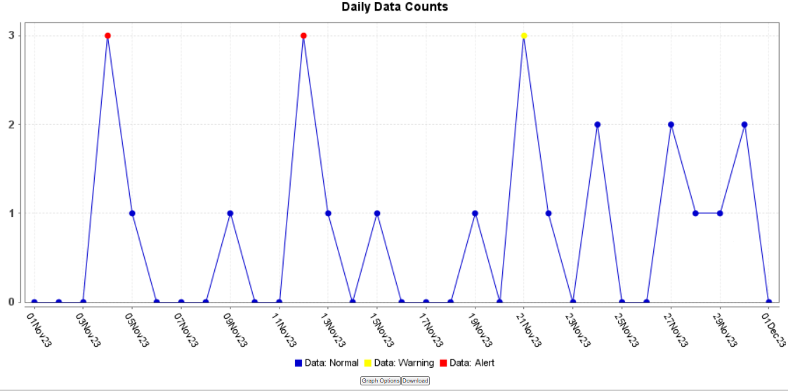

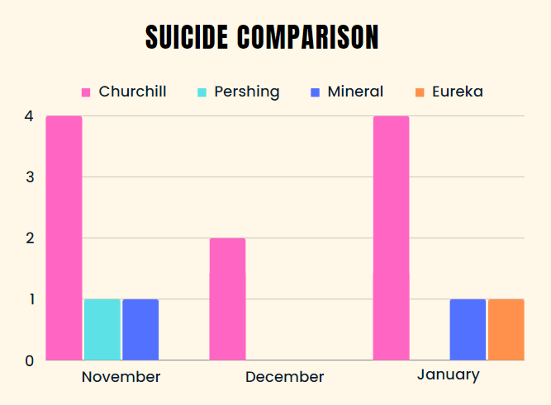

- What does this data mean?
  - It means that suicide ideations remain low in compared to national averages. The most recent suicide data released by the CDC as of 2021, showed there were 48,183 suicides in the Country, and 1.7 million attempts, and was the 11th leading cause of death.
  - Because our rates fluctuate month to month in our counties – we will continue to work to lower rates of suicide attempts and ideations.

Monitoring of Drug Overdose Data
- January 2024 data.
  - There were no alerts or warnings.
- December 2023 data.
  - There were no alerts or warnings.
- November 2023 data.
  - There were 5 alerts/warnings for November 2023.
    - 1 alert 11/13/23, male age 37, Churchill County.
    - 1 alert 11/14/23, male age 80, Churchill County.
    - 1 alert 11/16/23, male age 32, Mineral County.
    - 1 alert 11/17/23, male age 33, Churchill County 1 alert 11/23/23, male age 80, Churchill County.
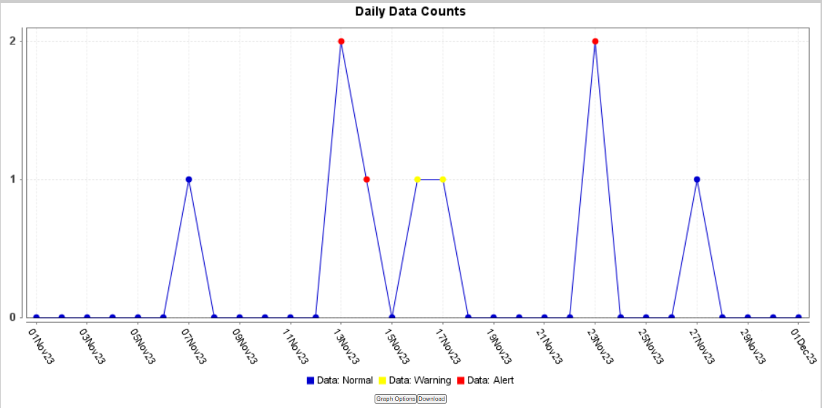

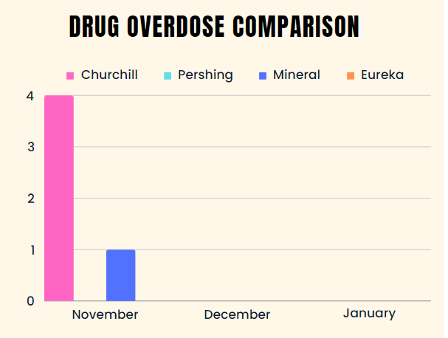

Monitoring of Opioid Deaths
- No recent deaths from opioid overdoses in any of the communities.

Key Take Aways from This Comparison Data
- January 2024 had an increase in suicide attempts compared to December 2023.
- December had less suicide attempts, and suicide ideations seen at emergency departments for all counties compared to November 2023.
- January and December had less drug overdose attempts/accidental overdoses.
- Opioid deaths remain at none.
- Teen suicide attempts are on the rise nationally. Any alert for a pediatric suicide attempt is concerning for us.
  - What will we need to do? Identify common risk factors for teen suicide attempts including mood disorders, alcohol and drug use, family history of suicide, and ongoing mental health issues.
  - Analyzing the rates of teen suicide attempts within our communities will allow us to create resources and support for teens to lower and eliminate cases. CNHD will advocate on suicide prevention within our communities.

Resources

- The Electronic Surveillance System for Early Notification of Community Based Epidemics (ESSENCE).
- American Foundation for Suicide Prevention.
- Centers for Disease Control and Prevention – Suicide Prevention.
- This report was prepared by Victoria Sepcic, MPH – CNHD Epidemiology Program Manager on 1/29/24.

2023-2024 CNHD Respiratory Surveillance Program December 31st, 2023 – January 27th, 2024 (MMWR weeks # 1-4)
Monthly Summary

The following information has been gathered from the National Electronic Disease Surveillance System (NEDSS), the CDC Weekly Influenza Surveillance Activity Data, the Nevada Department of Health and Human Services Office of Analytics, the Nevada Respiratory Dashboard, the Nevada COVID-19 Surveillance Dashboard, the CDC COVID-19 Data Tracker and the Electronic Surveillance System for Early Notification of Community Based Epidemics (ESSENCE).
This report was prepared on 1/29/24, by Victoria Sepcic, MPH; CNHD Epidemiology Program Manager.

Key message(s):
- Influenza activity is decreasing in most parts of the State and in the most parts of the Country but is holding steady locally.
- Locally, influenza rates are highest in Churchill, followed by Pershing, Mineral and Eureka.
- Influenza Like Illness (ILI) activity is highest in the ≥ 65-year age group.
- The most frequently identified influenza virus type reported by public health laboratories is influenza A, locally and nationally.
- Routine annual influenza vaccination is recommended for all persons aged 6 months or older, if there are no contraindications.
- RSV rates hold steady in all counties.
- Continued recommendations for the RSV vaccine for women 32-36 weeks pregnant, 1 dose of the RSV vaccine for infants aged 8 months and younger born during their first RSV season; and 1 dose of the RSV vaccine for infants and children aged 8-19 months who are at increased risk for severe RSV disease and entering their second RSV season; and 1 dose of the RSV vaccine to adults aged 60 years and older.
- COVID-19 cases are decreasing locally.
- Routine annual COVID-19 boosters are recommended to everyone aged 5 years and older.

Influenza and Influenza Like Illness (ILI)

- Flu season began on 10/1/23 (week 40) and with an estimated end date of 5/18/24. (The weeks are assigned by the Morbidity and Mortality Weekly Report (MMWR) Series. The MMWR week is assigned by the National Notifiable Disease Surveillance System (NNDSS) disease report for disease reporting and publishing).
- The average flu season lasts for 7 months.
- There are four types of influenza viruses: A, B, C, and D. Influenza A and B viruses cause the seasonal epidemics in which we refer to as the flu season.
- Flu rates peak typically in February, but can peak in December, January, and sometimes March.
- In the month of January 2024 (data dates 12/31/23-1/27/24) there were 132 flu cases reported.
  - 119 from Churchill County
  - 4 from Pershing County
  - 8 from Mineral County
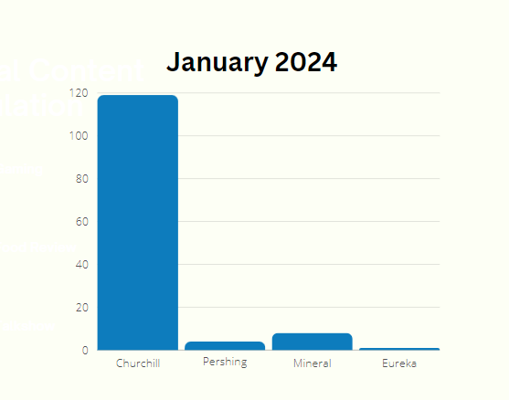
  - 1 from Eureka County

  - In the month of December there were 79 flu cases reported.
    - 71 from Churchill County
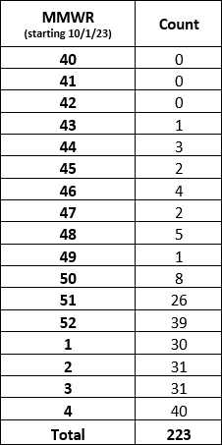
    - 8 from Pershing County
    - 0 from Mineral County*
    - 0 from Eureka County*

  - Since the start of the flu season there have been 223 flu cases in total.
    - 202 from Churchill County
    - 12 from Pershing County
    - 8 from Mineral County
    - 1 from Eureka County

  - There have been no flu related deaths this season from any of our counties for this current flu season.
    - An influenza-associated death is defined as a death resulting from a clinically compatible illness that was confirmed to be influenza by a laboratory or rapid diagnostic test with no period of complete recovery between the illness and death.

  - There has been only one flu related hospitalization from Churchill County in December.
    - Medical records are reviewed for cases with evidence of a positive influenza test who were hospitalized for greater than or equal to 24 hours.

  - Percent vaccinated for the flu:
    - 18.6% for Mineral (Population of 4,847 with 901 vaccinated)
    - 8.7% for Eureka (Population of 1,888 with 164 vaccinated)
    - 20.4% for Churchill (Population of 26,634 with 5,444 vaccinated)
    - 12.1% for Pershing (Population of 7,333 with 888 vaccinated)
  - The most frequently identified influenza virus type reported by public health laboratories continues to be influenza A, locally and nationally.

  - Influenza like illness (ILI) is defined as a fever (≥100°F) and cough and/or sore throat. ILI data is submitted weekly by inpatient and outpatient health services who have completed the onboarding process to be a sentinel surveillance provider. ILI activity levels use the proportion of outpatient visits to healthcare providers for respiratory illness, not laboratory confirmed influenza. ILI activity may capture patient visits due to other respiratory pathogens that cause similar symptoms to influenza.
  - Churchill, Pershing, Mineral and Eureka Counties present ILI at 2.86%, which is less than the State and below the National baseline. The State of Nevada presents ILI at 3.7% and National baseline is 4.3%
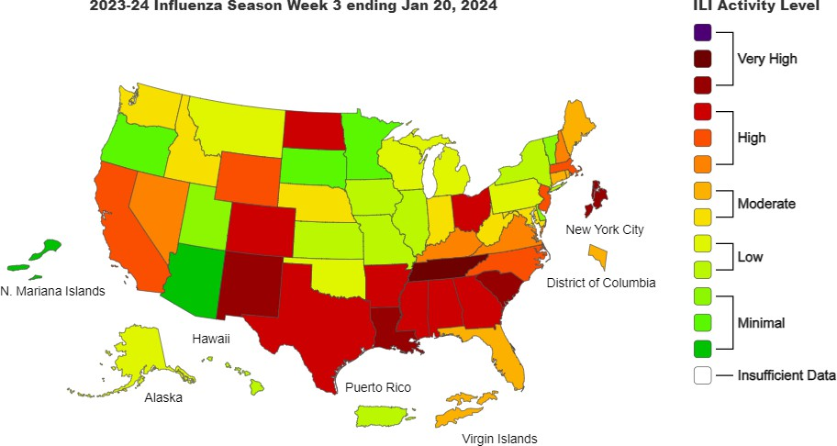

  - All four counties and the State of Nevada are in level HIGH for Influenza like illness (ILI) per CDC community transmission levels currently. (Data only available until January 20th)
  - There four sentinel providers that provide this data for the four Counties:
    - Banner Churchill Community Hospital
    - Pershing General Hospital
    - Renown Urgent Care – Fallon
    - Mt. Grant General Hospital

COVID-19

  - 47 new confirmed COVID-19 cases (PCR).
    - 35 cases from Churchill County
    - 0 cases from Eureka County
    - 2 cases from Pershing County
    - 10 cases from Mineral County

  - Total COVID-19 deaths
    - One new recent death. Last death was reported for Churchill County in January 2024.
    - Total deaths to date since 2020:
      - Churchill: 125
      - Pershing: 32
      - Mineral: 20
      - Eureka: 2

  - Hospitalizations
    - Churchill, Pershing and Mineral County is averaging 28 COVID-19 hospitalizations combined weekly for January. New COVID-19 hospital admissions per 100,000 population was 3%. The percent change in hospital admissions from December was 3.5%.
    - Eureka County had no new COVID-19 hospitalizations. New COVID-19 hospital admissions per 100,000 population was 6.6%. The percent change in hospital admissions from December was N/A.
    - COVID-19 hospital admission level for Churchill, Mineral, Pershing and Eureka was marked as low.
Vaccinations – current.
    - 6.5% of Churchill County has received the most recent recommended COVID-19 monovalent vaccine booster.
    - 5.7% of Mineral County has received the most recent recommended COVID-19 monovalent vaccine booster.
    - 3.2% of Pershing County has received the most recent recommended COVID-19 monovalent vaccine booster.
    - 2% of Eureka County has received the most recent recommended COVID-19 monovalent vaccine booster.

  - The counties are in level low for CDC community transmission levels currently.
  - Trends for new cases:
    - Churchill County last 3 months:
      - 1 new daily case in a 14-day moving average
      - 188 cases per 100,000 people.
    - Pershing County last 3 months:
      - 0 new daily cases in a 14-day moving average.
      - 27 cases per 100,000 people.
    - Mineral County last 3 months:
      - 0 new daily cases in a 14-day moving average.
      - 21 cases per 100,000 people.
    - Eureka County last 3 months:
      - 0 new daily cases in a 14-day moving average.
      - 0 cases per 100,000 people.

Respiratory Syncytial Virus (RSV)

- RSV is a common respiratory virus that can present with flu-like signs and symptoms (e.g., fever, coughing, runny nose). RSV, while usually presented with mild symptoms, can be serious, especially for infants and older adults. It is the most common cause of bronchiolitis and pneumonia in children younger than 1 year of age. RSV is a reportable condition in Nevada.
- 54 new RSV cases in January 2024.
- 127 total cases since 10/1/23.
- 120 cases from Churchill County.
  - 2 hospitalized cases from Churchill County.
- 3 cases from Mineral County.
- 1 case from Eureka County.
- 3 cases from Pershing County.
- No deaths this season from RSV.
- RSV rates continue to be steady weekly.
- The most prevalent age group for RSV are those in the 0-4 age group.
- There is also an increase in RSV amongst 65 and older.
- County School Nurses have been provided with updated RSV guidance and outbreak management within the schools.
Preventative Measures for Respiratory Viruses

- Wash your hands often with soap and water for at least 20 seconds, especially after coughing, sneezing, or blowing your nose.
- Cover your nose and mouth with a tissue or your elbow when you cough or sneeze and throw away the used tissue.
- Avoid touching your face.
- Social distance with those who are sick.
- Vaccinations
- Stay home if you are sick.
- If you must leave your house while you are experiencing symptoms, wear a mask to prevent the spread of respiratory droplets.
- Disinfect surfaces that may be contaminated with germs.

Resources

- The National Electronic Disease Surveillance System (NEDSS)
- The CDC Weekly Influenza Surveillance Activity Data
- The Nevada Department of Health and Human Services Office of Analytics
- The Nevada Respiratory Dashboard
- The Nevada COVID-19 Dashboard
- The Nevada COVID-19 Surveillance Dashboard
- The CDC COVID-19 Data Tracker
- The Electronic Surveillance System for Early Notification of Community Based Epidemics (ESSENCE)

